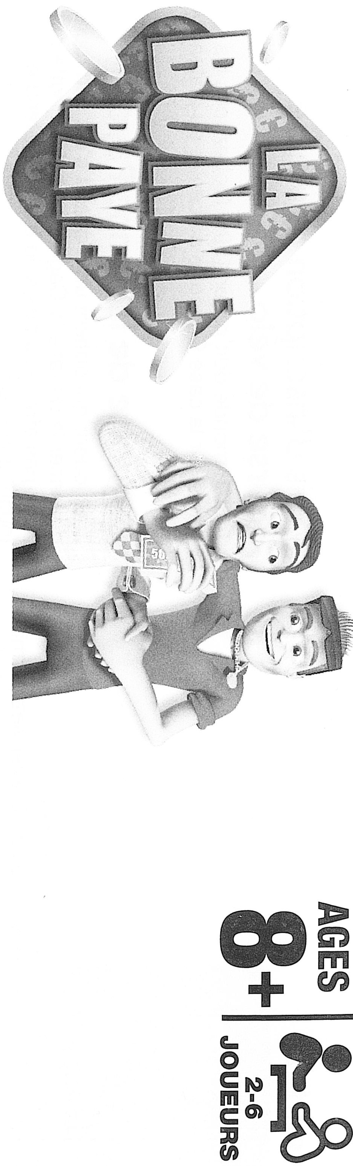

CONTENT

1 board game, 4 tokens, 23 ACQUISITION cards, 16 LOAN cards, 50 MAIL cards, 23 EVENT cards, 6 SAVING accounts, 1 PAY-DAY TODO LIST card, 1 stack of banknotes “La Bonne Paye” and 1 dice.

OBJECTIVE OF THE GAME

Be the player with the highest amount of money at the end of the game.

PREPARATION

1. Split the ACQUISITION, MAIL and EVENT cards in 3 distinct stacks and jumble each stack. Put the stack, hidden front on top, next to the board. Once used, each card is placed, face up, next to these stacks in order to make a new stack name the discard stack.
2. Choose one player that will be the banker. While playing the game, he/she will be responsible of the bank entries and exits. To start, the banker gives to each 1500€ and one token. The money is given as follows: 2 banknotes of 500€, 3 banknotes of 100€ and 4 banknotes of 50€.

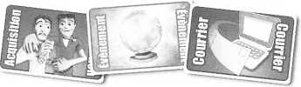

1. Put the PAY-DAY TODO LIST card next to the board. Remember to use this card when a player falls on the payday box.
2. Before the game starts, decide how many “months” you want to play, one “month” being a whole revolution of the board, from the START box to the PAYDAY box. You will have more time to make ACQUISITIONS, sell them and earn more money if you are playing for two or more months.
3. Put all the tokens on the START box. You are now ready to play!

GAME SEQUENCE

One of the player, the youngest for example, starts and the game continues clockwise.

At your turn

Roll the dice and move your token by the number of box given by the dice. Follow the instructions corresponding to the box you stop on (for more instruction, see the “BOARD” section);

THE BOARD

Each day of the month, there is something to do. Only the SUNDAY box allows you to relax by watching the other play.

Mail

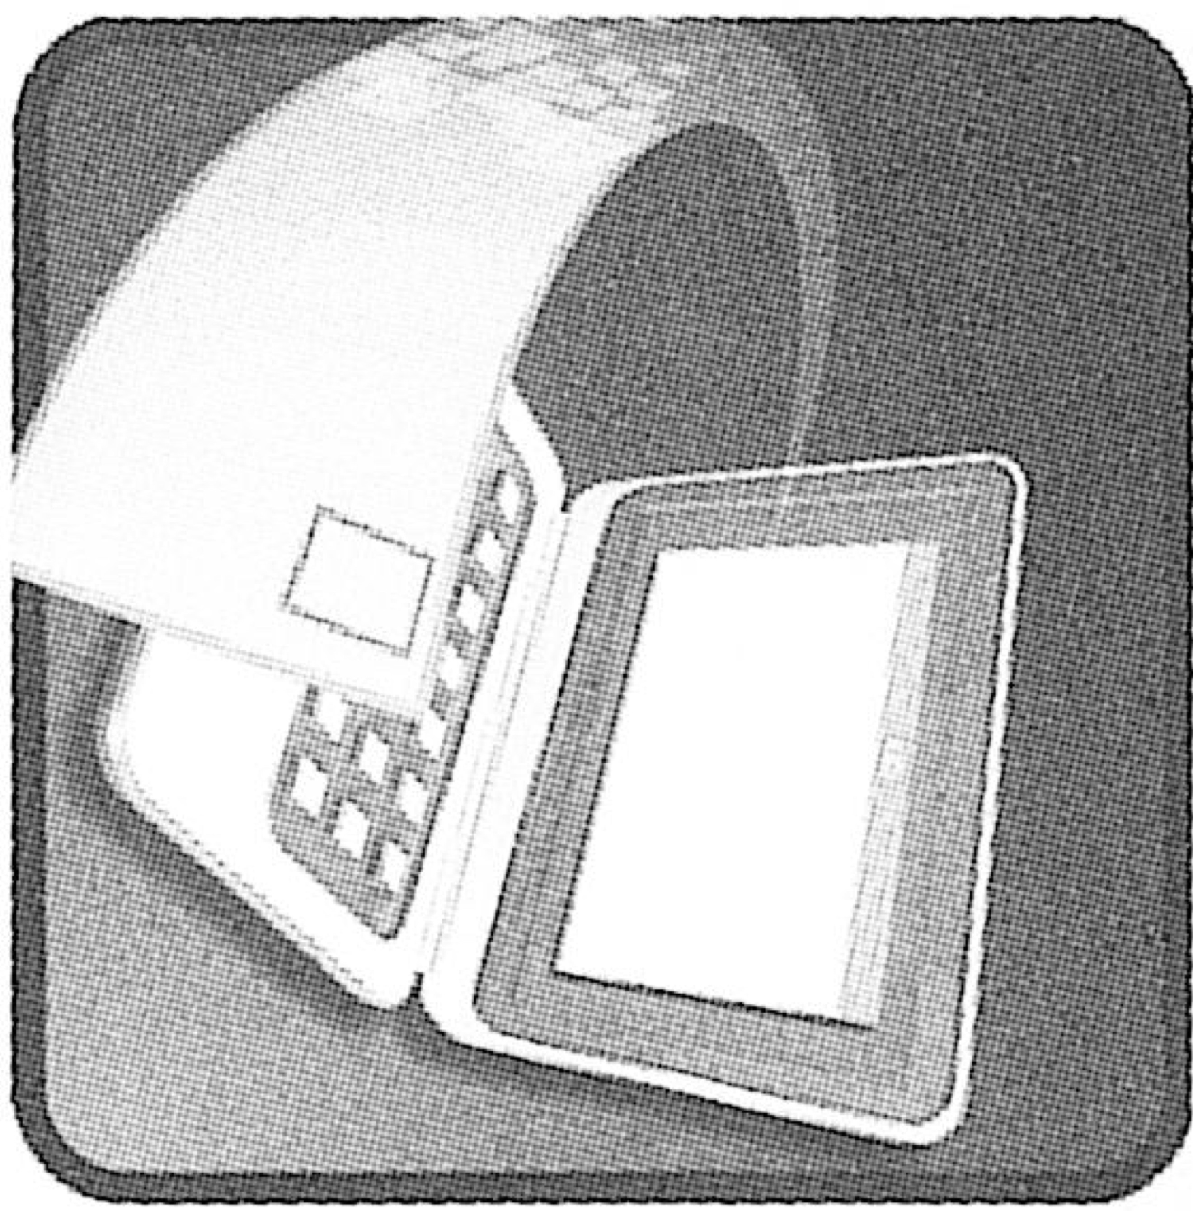Pick up as many MAIL card as written on the box. Do not open them, keep them until the end of the month, the PAYDAY box (for further instructions, see the section CARDS).

Acquisition

Pick up the first card of the ACQUISITION stack. If you are interested by the object to sell, pay the amount the bank and keep the card.

Otherwise, throw the card on the discard stack.

If your account is negative or if you don’t have enough money, you cannot buy any ACQUISITION!

Sell!



Now it’s time to sell one of your ACQUISITION card (if you have one). Choose one of your own card, the bank is buying you to its “real value”, as indicated on the card.

After selling each ACQUISITION, all players roll the dice. The commission, also indicated on the card, is paid by the bank to the player with the higher number.

Throw the ACQUISITION card on the discard stack.

What’s new?



Pick up the first card of the EVENT stack and follow the instruction. Then, throw this card on the discard stack.

Lottery

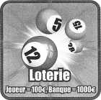

The bank gives 1000€ to the lottery at the beginning. Then, each player decides to play (but it’s not mandatory) and has to pay 100€. Each player that has paid choose a different number, between one and six. The player starting the lottery (arriving on the lottery box) choses first. When everybody has chosen, this player rolls the dice. If the number given by the dice is one of the chosen number, the player rounds up the bet. Otherwise, the dice is rolled again and again until someone wins.

Happy birthday

If you are stopping on this box, you receive a present in cash: each player gives you 150€!

Subscription fees to the bike race

Everybody have to pay 150€. The money goes to the central pot, in the center of the board.

Central pot of La Bonne Paye

When a player obtain 6 with the dice (only when rolling for moving the token), he/she win the central pot! The pot cannot be earned if obtained during lottery.

Hour change

When a player stops on this box, everybody move back one box and follow the instructions of the new box. If a player falls on the START box during an hour change, it get back to the 31st box and wins 1500€ from the bank! If one player falls on the Hour change while doing an hour change, this player goes to the ACQUISITION box of the 25th.

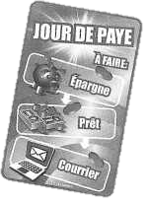PAYDAY

STOP! You need to stop here, even if the number on the dice drives you further away. Proceed as follows:

1. Receive from the bank 1500€ of monthly incomes
2. If your account balance is positive, earn 10% of its value. Otherwise, pay 10% of interests.
3. Read your mails and pay the bills. If you do not have enough money, create as much deficit as necessary on your account. Discard the MAIL cards (including thus that are not bills).
4. Put your token on the START box. When it will be your turn again, you will start a new month.

**Remark:** when you arrive on the PAYDAY box of the last month to play (depending on how many month you chose), stop playing and wait for the other to finish. Discard all your ACQUISITION cards. While waiting, you can still play the lottery but you have to pay for the birthday present of someone stopping on the “Happy anniversary” box.

CARDS

When a stack is finished, jumble the discard stack and use it as a new stack.

ACQUISITION card

These cards allows you to do profits. You can have as much as you want. If you think your rich, don’t bother and buy everything!

For example, the “Collier de Chier serti de diamants” will cost you 2850€. You can sell it 3600€, that is to say a benefit of 750€.

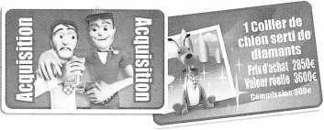

**Remark:** you can sell only one ACQUISITION when you stop on a SELL box. Once you have sold an ACQUISITION, it is discarded. Then roll the dice for the commission.

EVENT cards

What will your future be? You receive money from the bank or give some to the central pot. Follow the instructions on the card you have picked up and then discard the card.

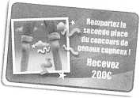

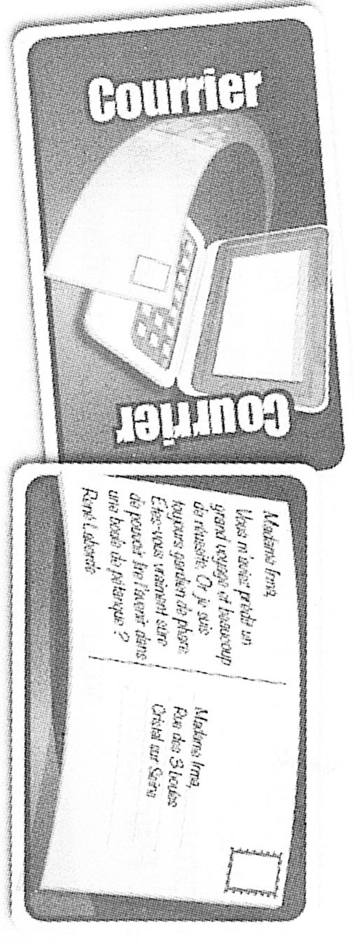

MAIL cards

Some mails are only letter. Just read them! But if you can also pick up:

1. Insurance

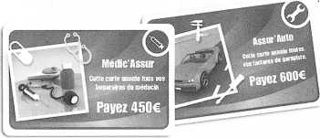

There are options, not mandatory. If you are interested, keep the card and pay the bank the written amount of money. If you are not, just discard the card. These cards are expensive of course but they also cancel respectively doctor bills and garage bills.

1. Bills

Pay all the bills you receive, only if you don’t have the corresponding insurance.

1. Need money?

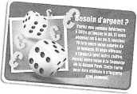

Bet a amount of money lower than 300€ and roll the dice. If you obtain 5 or 6, the bank gives you 10 times your bet. However, if you obtain something else, you lose your money that goes to the central pot. This card can be played whenever you want in the game (but you need to have read it!)

AND THE WINNER IS!

When all the players have done the number of months decided at the beginning of the game, each one calculate the total amount of money he/she has (every bill will have been paid on the PAYDAY box)/ The player with the highest amount of money wins the game.